

Acceptance Management Process©
For [Project Name]

Document Control

Document Information
 | Information
Document Id | [Document Management System #]
Document Owner | [Owner Name]
Issue Date | [Date]
Last Saved Date | [Date]
File Name | [Name]

Document History
Version | Issue Date | Changes
[1.0] | [Date] | [Section, Page(s) and Text Revised]

Document Approvals
Role© | Name | Signature | Date
Project Sponsor

Project Review Group

Project Manager©

Quality Manager
(if applicable)

Procurement Manager
(if applicable)

Communications Manager
(if applicable)

Project Office Manager
(if applicable)

Table of Contents

Template Guide 1
1 Acceptance Process 2
1.1 Overview 2
1.2 Complete Deliverable 4
1.3 Complete Acceptance Test 4
1.4 Review Acceptance Test 4
1.5 Accept Deliverable 4
2 Acceptance Roles 5
2.1 Project Manager 5
2.2 Customer 5
3 Acceptance Documents 5
3.1 Acceptance Register 5
3.2 Acceptance Form 5

Template Guide

What is an Acceptance Management Process?

An Acceptance Management Process is a method by which deliverables produced by the project are reviewed and accepted by the customer. The process entails completing a variety of review techniques to confirm that the deliverable meets the Acceptance Criteria outlined in the initial project Acceptance Plan. ©

An Acceptance Management Process is used to ensure that every deliverable produced by the project is formally:

- Completed
- Documented
- Reviewed
- Approved.

When to use an Acceptance Management Process

The Acceptance Management Process is undertaken towards the end of the ‘Execution’ phase of the project as each deliverable is completed, ready for customer sign-off. Depending on the project, one of several approaches may be taken by the customer to accept project deliverables: ©

- Each deliverable may be reviewed and presented individually to the customer for sign-off
- Sets of deliverables may be reviewed and presented for sign-off at the same time
- All project deliverables may be reviewed and presented for sign-off at the same time.

Without a formal Acceptance Management Process in place, the customer may not accept the final deliverables produced by the project, thereby compromising the project's overall success. The Acceptance Management Process is terminated only when the Execution phase of the project is completed (i.e. just prior to Project Closure). ©

How to use this template

This document provides a guide on the topics usually included in an Acceptance Management Process document. Sections may be added, removed or redefined at your leisure to meet your particular business circumstance. Example tables, diagrams and charts have been added (where suitable) to provide further guidance on how to complete each relevant section.

Acceptance Process

Overview
Provide an overview of the Acceptance Management Process. For example:

"The Acceptance Management Process is undertaken to measure project deliverables against clearly defined completion criteria and gain the customer's acceptance of each deliverable within the project." ©

Acceptance Management will be introduced to this project through the implementation of four key processes:

- The completion of project deliverables
- The undertaking of Acceptance Testing
- The review of Acceptance Test results
- The acceptance of the final deliverable by the customer. ©

The following diagram describes the processes and procedures required to gain the acceptance of project deliverables by the customer. Where applicable, Acceptance Roles have also been identified:
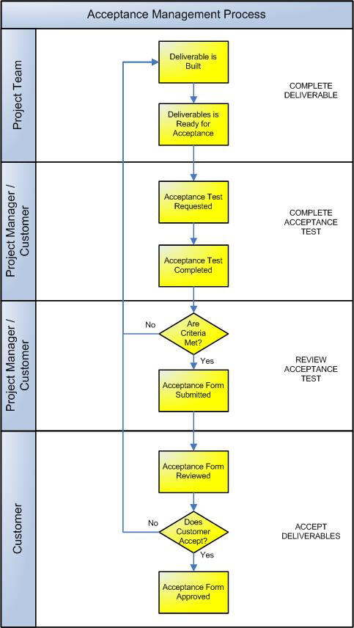

Complete Deliverable
This process involves undertaking all activities and tasks to complete the deliverable to a level which is likely to gain customer acceptance. The following procedures are instigated: ©

- Undertake all tasks required to complete the deliverable
- Document the final deliverable components
- Inform the Project Manager that the deliverable is now ready for customer acceptance.

Complete Acceptance Test
The Project Manager arranges an Acceptance Test of the deliverable by the customer to gain agreement that the deliverable matches the Acceptance Criteria and is now ready for final sign-off. This involves: ©

- Confirming that the Acceptance Test methods outlined in the Acceptance Plan are still relevant and appropriate. Examples of Acceptance Test methods include:

- Physical inspection of the deliverable
- Independent auditing of the deliverable (by a third party)
- Analysis of the processes used to complete the deliverable
- Review of the time taken against the Project Plan
- Review of the actual cost against the Financial Plan
- Review of the quality against the Quality Plan.

- Confirming that the Criteria and Resource outlined in the Acceptance Plan are still relevant and appropriate for the Acceptance Test
- Scheduling the Acceptance Test with the customer
- Undertaking the Acceptance Test with the customer
- Documenting the Acceptance Test results for final review by the customer.

Review Acceptance Test
The Acceptance Test results are viewed to determine whether they met the criteria specified within the Acceptance Plan. This involves: ©

- Reviewing the results against the original acceptance criteria
- Determining whether or not the criteria have been met, based on the results
- Initiating further work required to improve the deliverable if required
- Completing an Acceptance Form for deliverable approval.

Accept Deliverable
The deliverable is finally accepted by the customer. This involves: ©

- Reviewing the Acceptance Form to ensure that all final criteria have been met, processes have been undertaken and handover tasks outlined
- Obtaining customer sign-off on the Acceptance Form
- Initiating the listed handover tasks to transfer the deliverable from the project environment to the customer environment
- Initiating any support activities required for the deliverable now that it is considered operational at the customer environment.

Acceptance Roles

Define the roles and responsibilities for all resources (both internal and external to the project) involved with the review and acceptance of project deliverables. Examples include: ©

Project Manager
The Project Manager organizes the entire Acceptance Process for each deliverable produced by the project. The Project Manager is responsible for: ©

- Receiving notification from the project team that the deliverable is complete and ready for customer acceptance
- Organizing the Acceptance Testing of the deliverable with the customer, including scheduling the resources and facilities and documenting the test results
- Documenting the Acceptance Form ready for customer sign-off
- Undertaking the handover tasks required to transfer the deliverable from the project environment to the customer environment.

Customer
The customer is the final authority on deliverable sign-off. The customer is responsible for:
- Undertaking the Acceptance Test
- Reviewing the deliverable against the Acceptance Criteria to ensure that all required criteria have been met
- Authorizing the Acceptance Form to provide final confirmation that the deliverable has met the criteria specified within the Acceptance Plan
- Taking custody of the deliverable and providing a suitable operational environment (if applicable).

Acceptance Documents

List any other documentation used to manage the customer acceptance of deliverables within the project.

Acceptance Register
The ‘Acceptance Register’ is the log / database where all customer acceptance requests are registered and tracked through to approval. Insert a template for the Acceptance Register here to show how acceptance requests will be monitored for this project. (NB Refer to the Method123 ‘Acceptance Register’ template for a complete example).

Acceptance Form
The ‘Acceptance Form’ is used to request the acceptance of a deliverable produced by the project. Insert a template for the Acceptance Form here to show how acceptance requests will be raised on this project. (NB Refer to the Method123 ‘Acceptance Form’ for a complete example).

